Contents

Overview 2

Document History 2

Use Case / Timing 3

Audience 3

Security 3

Publishing Location 3

Reports to be Replaced or Consolidated 4

Data Requirements 4

Subject Areas, Facts and Dimensions / ODS tables and views 4

Static Report Filters: 4

User selected Prompts/Parameters: 4

On Screen Prompts/Parameters 4

Batch Schedule Prompts/Parameters 5

Report Layout / Mockup 5

6

Report Layout Data Columns 9

Measures 47

Assumptions/Dependencies 47

Developer Estimates: 47

Status: 47

Approvals 47

Appendix A: 48

Appendix B: 48

# Overview

|  |  |  |  |
| --- | --- | --- | --- |
| **Title:** | Property Record Card | | |
| Description: | The internal property record card is the most comprehensive report, displaying everything related to the folio. | | |
| Requested Date: |  | ServiceNow # |  |
| Required Date: | June 1, 2019 | Toolset: |  |
| Business Owner: |  | Functional Complexity: |  |
| Subject Matter Expert: |  | Technical Complexity: |  |

## Document History

|  |  |  |  |
| --- | --- | --- | --- |
| Version | Date | Author | Description |
| 01 |  |  |  |
|  |  |  |  |
|  |  |  |  |
|  |  |  |  |
|  |  |  |  |

# Use Case / Timing

*Describe the typical use case for this report including where it fits in the business process, when is the data available, and is there a specific time of year when it is used.*

|  |  |  |
| --- | --- | --- |
|  | Value | Restrictions |
| Produced | Throughout the year |  |
| Report Availability | Always Available |  |
| Usage Frequency | On demand, ad hoc | Internal use only |

# Audience

*Identify target audience and user level*

| **Group** | **Organization**  (for External only) | **Department**  (Internal or External) | **Role** | **User Level** |
| --- | --- | --- | --- | --- |
| Internal |  | Field Offices |  |  |
| External |  |  |  |  |

# Security

*Identify whether this report or data within is restricted for different clients / user security groups. May have multiple rows, one for each unique internal or external client/group as necessary.*

| **Group** | **Organization**  (for External Only) | **Restrictions on report access** | **Restrictions on data** | **Restrictions by user security group** |
| --- | --- | --- | --- | --- |
| Internal |  |  |  |  |
| External | N/A |  |  |  |

# Publishing Location

*Specific internal Business Analytics Portal folder location i.e. EDW Enterprise Reporting, Departmental, Sandbox, Business Area / Subject Area etc., or*

*External location i.e. Customer Portal and/or DDW*

*There may be a need to create and store general reports as of a specific date if that functionality is available with the SSRS tool.*

For internal consumers, this report must be available to run on demand via the Business Analytics Portal, Enterprise Reporting, XXX subject area, sub-section XXX.

# Reports to be Replaced or Consolidated

*N/A – if there are no reports providing this functionality?*

| **Replace / Consolidate** | **Report name** | **Reason** | **Current report location** |
| --- | --- | --- | --- |
| Replace | Property Record Card | valueBC will no longer be accessible | valueBC Property Viewer |

# Data Requirements

## Subject Areas, Facts and Dimensions / ODS tables and views

|  |  |
| --- | --- |
| Subject area / ODS | iasWorld ODS |
| Cube | N/A |
| Dimensions /  Reference tables  *List all that apply. Developer to verify and update.* | 1. All Tables |
| Facts / tables |  |

## Static Report Filters:

*Identify the data query filters that determine which folios will be included or excluded within this report. Static filters are not selectable; they are inherent and automatically applied at run time.*

| Element | Value | Comments |
| --- | --- | --- |
| N/A |  |  |

## User selected Prompts/Parameters:

*Identify the parameters that a user is prompted to select to control the data that is included within this report. Most reports are only available on demand. Some reports are required to be run by BCA and the output pushed to consumers automatically (batch or schedule).*

### On Screen Prompts/Parameters

The following parameters are to be available to internal and external consumers of this report when it is requested on demand.

| Element | Mandatory | Optional | Default | Value (sample) |
| --- | --- | --- | --- | --- |
| Roll Year | Select from list of all roll years. Display roll years in descending value: 2018, 2017… |  | Current roll year | 2018  2017 … |

### Batch Schedule Prompts/Parameters

The following parameters are to be available to Contact Center staff when this report is requested via a batch schedule. The output should be delivered directly to authorized customer’s DDW drop folders.

| Element | Mandatory | Optional | Default | Value (sample) |
| --- | --- | --- | --- | --- |
| N/A |  |  |  |  |

# Report Layout / Mockup

|  |  |
| --- | --- |
| Header/Footer, Font, etc. | Conform with global report standards / template for header and footer, font, etc. |
| Report Title | **Report title line 1**: Property Record Card <Roll Year Parameter> <Folio ID> |
| Page Break | Specify when to break to new page |
| Footer | * BCA Logo, Information Disclaimer, Run Date |
| Output sorting / hierarchies |  |
| Drill thru  *i.e. Summary vs detail* |  |
| Visualizations  *i.e. Pie Chart, Cross Tab, etc* |  |
| Sample layout | See existing report within W:\WorkingGroup Selected\Projects-Portfolio\Next Generation Value BC\BA\Tyler\Implementation\Reports\Sample Output Reports\INTERNAL PRC |
| Output format | PDF |
| Supporting information to be included in this report |  |
| Additional information |  |

*When available, insert screen capture or snippet of Mock up – here.*

## 

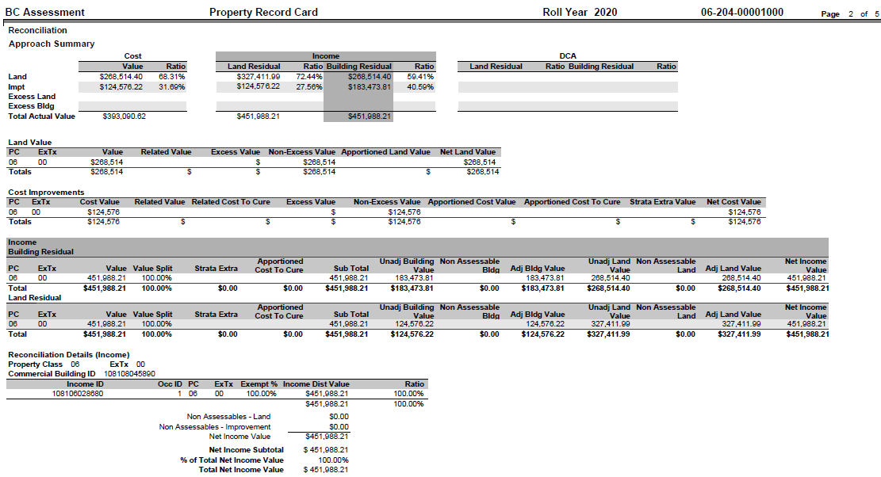

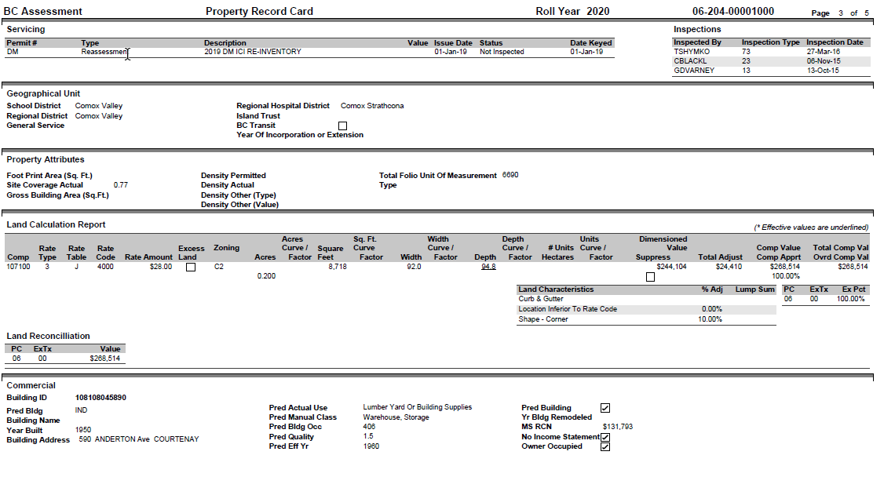

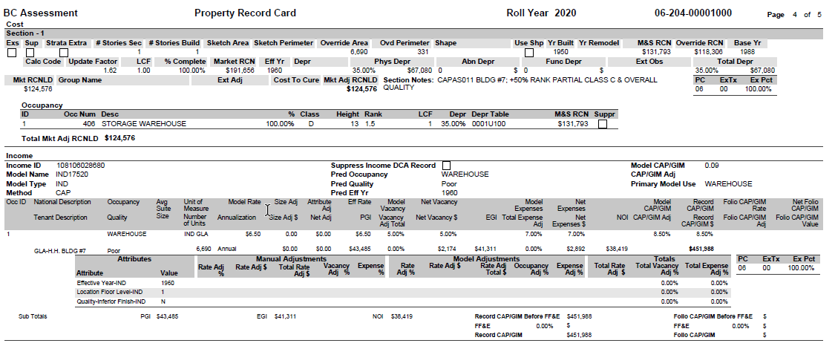

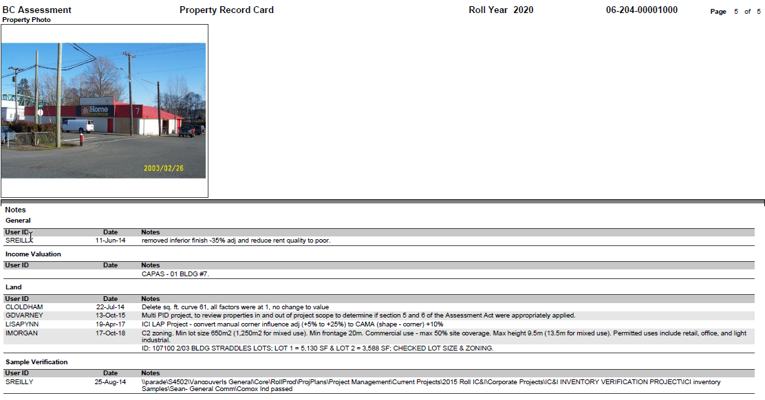

## Report Layout Data Columns

*Describe the body of the report.*

*Description: if column is not populated, refer to Data Dictionary for description*

*Privacy Concerns?: columns indicate if the data element is Confidential, Personal or Sensitive. These columns are populated only if there are concerns, and are blank if no concerns are identified.*

| Report Label / Column | Element  Description | Table | Field | Format / Derived (mandatory if calculated) | **Privacy Concerns?** | | |
| --- | --- | --- | --- | --- | --- | --- | --- |
| **Con** | **Per** | **Sen** |
| **Main Body of Report (columns listed vertically here and laid out horizontally within the physical report (left to right)).** | | | | | | | |
| **Section 1- the following fields are not laid out horizontally. See format for orientation** | | | | | | | |
| Area | Area of folio | PARDAT | AREACD | Left Justified, Line 1 |  |  |  |
| Jurisdiction | Jurisdiction of folio | PARDAT | MUNICD | Left justified, Line 2 |  |  |  |
| Roll Number | Roll # of folio | PARDAT | ROLLNO | Left justified, Line 3 |  |  |  |
| Status | Status of folio (active/inactive) | PARDAT | STATUS | Left justified, Line 4 |  |  |  |
| School District Code | School district name | LEGDAT | USER5 | Left justified, Line 5 |  |  |  |
| Neighbourhood | Neighborhood of folio | PARDAT | NBHD | Left justified, Line 6 |  |  |  |
| Situs | Property address | PARDAT | UNITNO, ADRPRE, ADRDIR, ADRSTR, ADRSUF, ADRSUF2, CITYNAME, STATECODE, POSTALCODE | Left justified, Line 7 |  |  |  |
| Owner | List of owner names | OWNDAT |  | Left justified, Line 8 |  |  |  |
| Owner Advisory | Owner advisory, if any | OWNDAT | USER12 | Left justified, Line 9 |  |  |  |
| Property Advisory | Property advisory, if any | PARDAT | USER39 | Left justified, Line 10 |  |  |  |
| Bulk Code | Bulk mail code | OWNDAT | USER14 | Center Left Justified, Line 1 |  |  |  |
| Land Dim Type | Acres or square footage |  |  | Center Left Justified, Line 2 |  |  |  |
| Acres | Size of land | LAND | ACRES | Center Left Justified, Line 3 |  |  |  |
| Depth | Depth of land | LAND | DEPTH | Center Left Justified, Line 4 |  |  |  |
| Tenure Code | Tenure code | LEGINFO | TENURECODE | Center Left Justified, Line 5 |  |  |  |
| Equity Type | Equity code | OWNDAT | USER7 | Center Left Justified, Line 6 |  |  |  |
| PID | PID from legal description | LEGINFO | PID | Center Left Justified, Line 7 |  |  |  |
| Parcel/Legal | Legal description | LEGINFO | <ALL FIELDS> | Center Left Justified, Line 8 |  |  |  |
| Latitude | Map value | LEGINFO | LATITUDE | Center Right Justified, Line 1 |  |  |  |
| Longitude | Map value | LEGINFO | LONGITUDE | Center Right Justified, Line 2 |  |  |  |
| NTS Loc | Map value | LEGINFO | NTSMAP | Center Right Justified, Line 3 |  |  |  |
| Map Number | Map Value | PARDAT | USER38 | Center Right Justified, Line 4 |  |  |  |
| ALR Code | ALR coding on folio, if present | PARDAT | USER3 | Center Right Justified, Line 5 |  |  |  |
| F.N. Reserve # | From Legal Description | LEGINFO | FNRESERVE | Center Right Justified, Line 6 |  |  |  |
| OGC Project # | From Legal Description | LEGINFO | PROJECTNO | Center Right Justified, Line 7 |  |  |  |
| OGC WA # | From Legal Description | LEGINFO | WANUM | Center Right Justified, Line 8 |  |  |  |
| OGC File # | From Legal Description | LEGINFO | TENURENO | Center Right Justified, Line 9 |  |  |  |
| OGC Field Name | From Legal Description | LEGINFO | WELLNAME | Center Right Justified, Line 10 |  |  |  |
| Construction Cost | Cost of dwelling | PARDAT | USER10 | Center Right Justified, Line 11 |  |  |  |
| Construction Date | Date dwelling built | PARDAT | USER11 | Center Right Justified, Line 12 |  |  |  |
| ECF | External cost factor | APRVAL | ECF | Center Right Justified, Line 13 |  |  |  |
| Group Name | Group name if affiliated with group | PARCELGRP_MST | GRPNAME | Center Right Justified, Line 14 |  |  |  |
| Complex Name | Complex name, if present | PARDAT | USER36 | Center Right Justified, Line 15 |  |  |  |
| Predominant Manual Class | Predominant Manual Class | PARDAT | CLASS | Right Justified, Line 1 |  |  |  |
| Land Use Code | Primary Actual Use Code | PARDAT | LUC | Right Justified, Line 2 |  |  |  |
| Vacant Flag | Checkbox |  |  | Right Justified, Line 3 |  |  |  |
| Valuation Method | Value method | APRVAL | REVCODE | Right Justified, Line 4 |  |  |  |
| Land Method | Land or building residual | APRVAL | REVMETH | Right Justified, Line 5 |  |  |  |
| Folio Characteristics | Folio characteristics, may be more than one | PARDAT | USER31, USER32, USER33, USER34, USER35 | Right Justified, Line 6 |  |  |  |
| Primary Flag | Checkbox | PARDAT | USER19 | Right Justified, Line 7 |  |  |  |
| Child | Checkbox |  |  | Right Justified, Line 8 |  |  |  |
| Under Appeal | Checkbox |  |  | Right Justified, Line 9 |  |  |  |
| Strata | Strata info |  |  | Right Justified, Line 10 |  |  |  |
| Strata Unit Net Area | Strata area |  |  | Right Justified, Line 11 |  |  |  |
| Corp(s) Total Area | Corporation area |  |  | Right Justified, Line 12 |  |  |  |
| Predominant Use Type | Predominant income | IEREC | USE | Right Justified, Line 13 |  |  |  |
| **Section 2 – Sales (THIS SHOULD BE A REPEATING LINE TO RECORD MULTIPLE SALES)** | | | | | | | |
| Sales Type | Type of document- sale/share transfer | SALES | SALETYPE |  |  |  |  |
| Document # | Document number from ltsa | SALES | INSTRUNO |  |  |  |  |
| Sale Date | Date of sale | SALES | SALEDT |  |  |  |  |
| Sale Price | Purchase price | SALES | PRICE |  |  |  |  |
| Sale Validity Code | Status of sale- qualified/reject | SALES | SALEVAL |  |  |  |  |
| **Section 3 – Value Summary** | | | | | | | |
| Assessed Value | Assessed value from latest roll | (PRIOR YEAR)APRVAL |  | This value is displayed in three lines: Land, Improvements, and Total |  |  |  |
| Actual Value | Assessed value from roll in progress | APRVAL |  | This value is displayed in three lines: Land, Improvements, and Total |  |  |  |
| **Subsection 3a - Actual Land (THIS SHOULD BE A REPEATING LINE FOR ALL ‘L’ TYPE RECORDS)** | | | | | | | |
| Property Class | Property class | APRVALSUM |  |  |  |  |  |
| EX Code | Exempt tax code | APRVALSUM |  |  |  |  |  |
| Actual Value | value of land from current roll year | APRVALSUM |  |  |  |  |  |
| Override Value | Override value if present in current roll year | APRVALSUM |  |  |  |  |  |
| Actual Land Value | Total value of land from current roll year | APRVALSUM |  |  |  |  |  |
| **Subsection 3b - Actual Improvement (THIS SHOULD BE A REPEATING LINE FOR ALL ‘I’ TYPE RECORDS)** | | | | | | | |
| Property Class | Property class | APRVALSUM |  |  |  |  |  |
| EX Code | Exempt tax code | APRVALSUM |  |  |  |  |  |
| Actual Value | Value of improvement from current roll year | APRVALSUM |  |  |  |  |  |
| Override Value | Override value, if present in current roll year | APRVALSUM |  |  |  |  |  |
| Actual Improvement Value | Total value of improvement from current roll year | APRVALSUM |  |  |  |  |  |
| **Subsection 3c - Assessed Land (THIS SHOULD BE A REPEATING LINE FOR ALL ‘L’ TYPE RECORDS)** | | | | | | | |
| Property Class | Property class | (PRIOR YEAR) APRVALSUM |  |  |  |  |  |
| EX Code | Exempt tax code | (PRIOR YEAR) APRVALSUM |  |  |  |  |  |
| Assessed Value | value of land from the published roll | (PRIOR YEAR) APRVALSUM |  |  |  |  |  |
| Override Value | Override value if present in published roll | (PRIOR YEAR) APRVALSUM |  |  |  |  |  |
| Assessed Land Value | Total value of land from published roll | (PRIOR YEAR) APRVALSUM |  |  |  |  |  |
| **Subsection 3d - Assessed Improvement (THIS SHOULD BE A REPEATING LINE FOR ALL ‘I’ TYPE RECORDS)** | | | | | | | |
| Property Class | Property class | (PRIOR YEAR) APRVALSUM |  |  |  |  |  |
| EX Code | Exempt tax code | (PRIOR YEAR) APRVALSUM |  |  |  |  |  |
| Assessed Value | Value of improvement from published roll | (PRIOR YEAR) APRVALSUM |  |  |  |  |  |
| Override Value | Override value, if present from published roll | (PRIOR YEAR) APRVALSUM |  |  |  |  |  |
| Assessed Improvement Value | Total value of improvement from published roll | (PRIOR YEAR) APRVALSUM |  |  |  |  |  |
| **Section 4 – Reconciliation** | | | | | | | |
| Approach Summary | sub-header |  |  | Located above three mini-tables: Cost, Income, DCA (all three tables share the same vertical axis/labels) |  |  |  |
|  | Three section titles: Cost, Income, DCA |  |  |  |  |  |  |
|  | Two headers under Cost: Value, Ratio |  |  |  |  |  |  |
|  | Four headers under Income: Land Residual, Ratio, Building Residual, Ratio |  |  |  |  |  |  |
|  | Four headers under DCA: Land Residual, Ratio, Building Residual, Ratio |  |  |  |  |  |  |
| Land | For Cost table, Value column | LAND |  |  |  |  |  |
|  | For Cost table, Ratio column |  |  |  |  |  |  |
|  | For Income table, Land Residual column |  |  |  |  |  |  |
|  | For Income table, Ratio column |  |  |  |  |  |  |
|  | For Income table, Building Residual column |  |  |  |  |  |  |
|  | For Income table, Ratio column |  |  |  |  |  |  |
|  | For DCA table, Land Residual column |  |  |  |  |  |  |
|  | For DCA table, Ratio column |  |  |  |  |  |  |
|  | For DCA table, Building Residual column |  |  |  |  |  |  |
|  | For DCA table, Ratio column |  |  |  |  |  |  |
| Improvement | For Cost table, Value column |  |  |  |  |  |  |
|  | For Cost table, Ratio column |  |  |  |  |  |  |
|  | For Income table, Land Residual column |  |  |  |  |  |  |
|  | For Income table, Ratio column |  |  |  |  |  |  |
|  | For Income table, Building Residual column |  |  |  |  |  |  |
|  | For Income table, Ratio column |  |  |  |  |  |  |
|  | For DCA table, Land Residual column |  |  |  |  |  |  |
|  | For DCA table, Ratio column |  |  |  |  |  |  |
|  | For DCA table, Building Residual column |  |  |  |  |  |  |
|  | For DCA table, Ratio column |  |  |  |  |  |  |
| Excess Land | For Cost table, Value column |  |  |  |  |  |  |
|  | For Cost table, Ratio column |  |  |  |  |  |  |
|  | For Income table, Land Residual column |  |  |  |  |  |  |
|  | For Income table, Ratio column |  |  |  |  |  |  |
|  | For Income table, Building Residual column |  |  |  |  |  |  |
|  | For Income table, Ratio column |  |  |  |  |  |  |
|  | For DCA table, Land Residual column |  |  |  |  |  |  |
|  | For DCA table, Ratio column |  |  |  |  |  |  |
|  | For DCA table, Building Residual column |  |  |  |  |  |  |
|  | For DCA table, Ratio column |  |  |  |  |  |  |
| Excess Building | For Cost table, Value column |  |  |  |  |  |  |
|  | For Cost table, Ratio column |  |  |  |  |  |  |
|  | For Income table, Land Residual column |  |  |  |  |  |  |
|  | For Income table, Ratio column |  |  |  |  |  |  |
|  | For Income table, Building Residual column |  |  |  |  |  |  |
|  | For Income table, Ratio column |  |  |  |  |  |  |
|  | For DCA table, Land Residual column |  |  |  |  |  |  |
|  | For DCA table, Ratio column |  |  |  |  |  |  |
|  | For DCA table, Building Residual column |  |  |  |  |  |  |
|  | For DCA table, Ratio column |  |  |  |  |  |  |
| **Summary Line:** | | | | | | | |
| Total Actual Value | For Cost table, Value column |  |  |  |  |  |  |
|  | For Income table, Land Residual column |  |  |  |  |  |  |
|  | For Income table, Building Residual column |  |  |  |  |  |  |
|  | For DCA table, Land Residual column |  |  |  |  |  |  |
|  | For DCA table, Building Residual column |  |  |  |  |  |  |
| **Subsection 4a – Land Value** | | | | | | | |
| Property Class | Property Class |  |  |  |  |  |  |
| EX Code | Exempt tax code |  |  |  |  |  |  |
| Value | Value of land record, displayed in dollar amount |  |  |  |  |  |  |
| Related Value | Related value, displayed in dollar amount |  |  |  |  |  |  |
| Excess Value | Excess value, displayed in dollar amount |  |  |  |  |  |  |
| Non-Excess Value | Non-excess value, displayed in dollar amount |  |  |  |  |  |  |
| Apportioned Land Value | Apportioned land value, displayed in dollar amount |  |  |  |  |  |  |
| Net Land Value | Net land value, displayed in dollar amount |  |  |  |  |  |  |
| **Subsection 4b- Cost Improvements** | | | | | | | |
| Property Class | Property Class |  |  |  |  |  |  |
| EX Code | Exempt tax code |  |  |  |  |  |  |
| Cost Value | Cost value, displayed in dollar amount |  |  |  |  |  |  |
| Related Value | Related value, displayed in dollar amount |  |  |  |  |  |  |
| Related Cost to Cure | Related cost to cure amount, displayed in dollar amount |  |  |  |  |  |  |
| Excess Value | Excess value, displayed in dollar amount |  |  |  |  |  |  |
| Non-Excess Value | Non-excess value, displayed in dollar amount |  |  |  |  |  |  |
| Apportioned Cost Value | Apportioned cost value, displayed in dollar amount |  |  |  |  |  |  |
| Apportioned Cost to Cure | Apportioned cost to cure, displayed in dollar amount |  |  |  |  |  |  |
| Strata Extra Value | Strata extra value, displayed in dollar amount |  |  |  |  |  |  |
| Net Cost Value | Net land value, displayed in dollar amount |  |  |  |  |  |  |
| **Subsection 4c – Income: Building Residual** | | | | | | | |
| Property Class | Property Class |  |  |  |  |  |  |
| EX Code | Exempt tax code |  |  |  |  |  |  |
| Value | value, displayed in dollar amount |  |  |  |  |  |  |
| Value Split | Value split, displayed as a percentage |  |  |  |  |  |  |
| Strata Extra | Strata extra, displayed in dollar amount |  |  |  |  |  |  |
| Apportioned Cost to Cure | Apportioned cost to cure, displayed in dollar amount |  |  |  |  |  |  |
| Sub Total | Sub total value amount |  |  |  |  |  |  |
| Unadj Building value | Unadj Building value |  |  |  |  |  |  |
| Non Assessable building | Non Assessable building |  |  |  |  |  |  |
| Adj building value | Adj building value |  |  |  |  |  |  |
| Unadj land value | Unadj land value |  |  |  |  |  |  |
| Non Assessable Land | Non Assessable Land |  |  |  |  |  |  |
| Adj Land Value | Adj Land Value |  |  |  |  |  |  |
| Net Income Value | Net Income Value |  |  |  |  |  |  |
| **Subsection 4d – Income: Land Residual** | | | | | | | |
| Property Class | Property Class |  |  |  |  |  |  |
| EX Code | Exempt tax code |  |  |  |  |  |  |
| Value | value, displayed in dollar amount |  |  |  |  |  |  |
| Value Split | Value split, displayed as a percentage |  |  |  |  |  |  |
| Strata Extra | Strata extra, displayed in dollar amount |  |  |  |  |  |  |
| Apportioned Cost to Cure | Apportioned cost to cure, displayed in dollar amount |  |  |  |  |  |  |
| Sub Total | Sub total value amount |  |  |  |  |  |  |
| Unadj Building value | Unadj Building value |  |  |  |  |  |  |
| Non Assessable building | Non Assessable building |  |  |  |  |  |  |
| Adj building value | Adj building value |  |  |  |  |  |  |
| Unadj land value | Unadj land value |  |  |  |  |  |  |
| Non Assessable Land | Non Assessable Land |  |  |  |  |  |  |
| Adj Land Value | Adj Land Value |  |  |  |  |  |  |
| Net Income Value | Net Income Value |  |  |  |  |  |  |
| **Subsection 4e – DCA: Building Residual** | | | | | | | |
| Property Class | Property Class |  |  |  |  |  |  |
| EX Code | Exempt tax code |  |  |  |  |  |  |
| Value | value, displayed in dollar amount |  |  |  |  |  |  |
| Value Split | Value split, displayed as a percentage |  |  |  |  |  |  |
| Strata Extra | Strata extra, displayed in dollar amount |  |  |  |  |  |  |
| Apportioned Cost to Cure | Apportioned cost to cure, displayed in dollar amount |  |  |  |  |  |  |
| Sub Total | Sub total value amount |  |  |  |  |  |  |
| Unadj Building value | Unadj Building value |  |  |  |  |  |  |
| Non Assessable building | Non Assessable building |  |  |  |  |  |  |
| Adj building value | Adj building value |  |  |  |  |  |  |
| Unadj land value | Unadj land value |  |  |  |  |  |  |
| Non Assessable Land | Non Assessable Land |  |  |  |  |  |  |
| Adj Land Value | Adj Land Value |  |  |  |  |  |  |
| Net Income Value | Net Income Value |  |  |  |  |  |  |
| **Subsection 4f- DCA: Land Residual** | | | | | | | |
| Property Class | Property Class |  |  |  |  |  |  |
| EX Code | Exempt tax code |  |  |  |  |  |  |
| Value | value, displayed in dollar amount |  |  |  |  |  |  |
| Value Split | Value split, displayed as a percentage |  |  |  |  |  |  |
| Strata Extra | Strata extra, displayed in dollar amount |  |  |  |  |  |  |
| Apportioned Cost to Cure | Apportioned cost to cure, displayed in dollar amount |  |  |  |  |  |  |
| Sub Total | Sub total value amount |  |  |  |  |  |  |
| Unadj Building value | Unadj Building value |  |  |  |  |  |  |
| Non Assessable building | Non Assessable building |  |  |  |  |  |  |
| Adj building value | Adj building value |  |  |  |  |  |  |
| Unadj land value | Unadj land value |  |  |  |  |  |  |
| Non Assessable Land | Non Assessable Land |  |  |  |  |  |  |
| Adj Land Value | Adj Land Value |  |  |  |  |  |  |
| Net Income Value | Net Income Value |  |  |  |  |  |  |
| **Subsection 4g – Reconciliation Details (Income)** | | | | | | | |
| **Sub-Header:** | | | | | | | |
| Property Class | Property Class |  |  |  |  |  |  |
| EX Code | Exempt tax code |  |  | Located to the right of ‘property class’ |  |  |  |
| Commercial Building ID | Commercial Building ID |  |  |  |  |  |  |
| **Main Table: (MAY HAVE REPEATING TABLES FOR MULTIPLE INCOME IDs)** | | | | | | | |
| Income ID | Income ID |  |  |  |  |  |  |
| Occupancy ID | Occ ID |  |  |  |  |  |  |
| Property Class | Property Class |  |  |  |  |  |  |
| EX Code | Exempt tax code |  |  |  |  |  |  |
| Exempt % | Exempt % |  |  |  |  |  |  |
| Income Dist Value | Income Dist Value, displayed in dollar amount |  |  |  |  |  |  |
| Ratio | Ratio, displayed as percentage |  |  |  |  |  |  |
| *Note the above two sections may be repeated if there are building IDs in different property classes. For example, see sample output report ‘Commercial With Apartment’ | | | | | | | |
| **Summary Lines of Table * Located underneath ‘Income Dist Value’ column for each table** | | | | | | | |
| Non Assessables – Land | Non Assessables – Land |  |  |  |  |  |  |
| Non Assessables – Improvement | Non Assessables – Improvement |  |  |  |  |  |  |
| Net Income Value | Net Income Value |  |  |  |  |  |  |
| **Summary Lines of Multiple Tables *Located underneath all tables in that property class section** | | | | | | | |
| Net Income Subtotal | Net Income Subtotal |  |  |  |  |  |  |
| % of Total Net Income Value | % of Total Net Income Value |  |  |  |  |  |  |
| Total Net Income Value | Total Net Income Value |  |  |  |  |  |  |
|  |  |  |  |  |  |  |  |
| **Section 5 – Related Folios (REPEATING LINES FOR MULTIPLE RELATED FOLIOS)** | | | | | | | |
| Folio ID | Folio ID of related folio |  |  |  |  |  |  |
| Relationship | Type of relationship |  |  |  |  |  |  |
| Status | Folio status |  |  |  |  |  |  |
| Situs | Situs address |  |  |  |  |  |  |
| Predominant Manual Class | Predominant manual class |  |  |  |  |  |  |
| Pred Pct Dev | Predominant % dev |  |  |  |  |  |  |
| Primary | Primary checkbox |  |  |  |  |  |  |
| Strata | Strata |  |  |  |  |  |  |
| Corp Tot Area | Corporation total area |  |  |  |  |  |  |
| Strata Unit Net Area | Strata unit net area |  |  |  |  |  |  |
| **Section 6 – Servicing (REPEATING LINES FOR MULTIPLE PERMITS)** | | | | | | | |
| Permit ID | Permit number | PERMIT | NUM |  |  |  |  |
| Type | Type of record- permit, income request, etc | PERMIT | WHY |  |  |  |  |
| Description | Description of permit | PERMIT | USER41 |  |  |  |  |
| Amount | Numerical dollar value | PERMIT | AMOUNT |  |  |  |  |
| Issue Date | Date issued | PERMIT | PRMDT |  |  |  |  |
| Status | Status of permit | PERMIT | USER2 |  |  |  |  |
| Date Keyed | Date permit added to system | PERMIT | UDATE3 |  |  |  |  |
| **Section 7 – Inspections (REPEATING LINES FOR MULTIPLE INSPECTIONS)** | | | | | | | |
| Inspected By | Who inspected folio | ENTER | ENTERID | Located to right of Servicing Section |  |  |  |
| Inspection Type | Type of inspection completed | ENTER | ENTERCD |  |  |  |  |
| Inspection Date | Date of inspection | ENTER | ENTERDT |  |  |  |  |
| **Section 8 – Geographical Units** | | | | | | | |
| School District | School district name | LEGDAT | USER5 | Left justified, line 1 |  |  |  |
| Regional District | Regional district name | LEGDAT | USER3 | Left justified, line 2 |  |  |  |
| General Service | General service area name | LEGDAT | USER4 | Left justified, line 3 |  |  |  |
| Regional Hospital District | Regional hospital district name | LEGDAT | USER1 | Right justified, line 1 |  |  |  |
| Island Trust | Name of island trust, if present | LEGDAT | USER2 | Right justified, line 2 |  |  |  |
| BC Transit | Checkbox | LEGDAT | USER8 | Right justified, line 3 |  |  |  |
| Year of Incorporation | Year of Incorporation | PARDAT | USER24 | Right justified, line 4 |  |  |  |
| **Section 9 - Property Attributes** | | | | | | | |
| Foot Print Area (Sq.Ft.) | Foot print area value | PARDAT | USER23 |  |  |  |  |
| Site Coverage Actual | Site coverage area value | PARDAT  (note-currently on APRVAL, but being moved) | USERVAL15 |  |  |  |  |
| Gross Building Area (Sq.Ft.) | Gross building area value | PARDAT | BLDGROS_V |  |  |  |  |
| Density Permitted | Density permitted value | PARDAT  (note-currently on APRVAL, but being moved) | USERVAL11 |  |  |  |  |
| Density Actual | Actual density value | PARDAT  (note-currently on APRVAL, but being moved) | USERVAL12 |  |  |  |  |
| Density Type | Additional density, defined | PARDAT  (note-currently on APRVAL, but being moved) | USER3 |  |  |  |  |
| Density Other Value | Additional density value | PARDAT  (note-currently on APRVAL, but being moved) | USERVAL13 |  |  |  |  |
| Total Folio Unit of Measurement | Numerical value for total units of folio measurement | PARDAT | USER25 |  |  |  |  |
| Type | Type of unit of measurement on folio | PARDAT | USER26 |  |  |  |  |
| **Section 10 - Land Calculation Report** | | | | | | | |
| Land Line # | Land line number | LAND | LLINE |  |  |  |  |
| Rate Type | Rate type | LAND | LTYPE |  |  |  |  |
| Rate Table | Rate table | LAND | MODTYPE |  |  |  |  |
| Rate Table Descr. | Rate code | LAND | CODE |  |  |  |  |
| Applied Rate | Rate code amount per sqft/acre | LAND | (label is ‘applied rate’) |  |  |  |  |
| Excess Land | Checkbox | LAND | EXCESS |  |  |  |  |
| Zoning | Zoning | LAND | USER6 |  |  |  |  |
| Acres | Land size in acres | LAND | ACRES |  |  |  |  |
| Acres Curve/Factor | Acres curve/factor |  |  |  |  |  |  |
| Square Feet | Land size in square feet | LAND | SF |  |  |  |  |
| Sq.Ft. Curve/Factor | Sq.Ft. Curve/Factor |  |  |  |  |  |  |
| Width | Width of land | LAND | FRONACT |  |  |  |  |
| Width Curve/Factor | Width Curve/Factor |  |  |  |  |  |  |
| Depth | Depth of land | LAND | DEPTH |  |  |  |  |
| Depth Curve/Factor | Depth Curve/Factor |  |  |  |  |  |  |
| Hectares | Land size in hectares | LAND | HECTARES |  |  |  |  |
| Units | Number of units | LAND | UNITS |  |  |  |  |
| Units Curve/Factor | Units Curve/Factor |  |  |  |  |  |  |
| Dimensioned Value | Dimensioned Value | LAND | BRATE |  |  |  |  |
| Suppress | Checkbox | LAND | SUPPRESS |  |  |  |  |
| Total Adjust | Total adjustment value | LAND & LANDFEAT | FLDFACT + LOCFACT + MKTFACT + SIZEFACT + TOPOFACT + LUMP1 + LUMP2 + ALL RECORDS ON LANDFEAT | CALCULATED AMOUNT DISPLAYED AS A DOLLAR VALUE AMOUNT |  |  |  |
| Value | Component value | LAND | PRICE |  |  |  |  |
| Allocation % | Component apportionment | LAND | ALLOCPCT | Located Underneath Comp Value |  |  |  |
| Value | Total component value | LAND | PRICE |  |  |  |  |
| Override Value | Override component value | LAND | OVRPRICE | Located Underneath Total Comp Value |  |  |  |
| **Subsection 10a (may have repeating lines for multiple adjustment types)** | | | | | | | |
| Adjustment Type | Adjustment Type | LAND | USER1 OR USER2 OR USER3 OR USER4 OR USER5 OR LUMPCD1 OR LUMPCD2 |  |  |  |  |
| % Adj | % Adj | LAND | FLDFACT OR LOCFACT OR MKTFACT OR SIZEFACT OR TOPOFACT |  |  |  |  |
| Lump Sum | Lump Sum | LAND | LUMP1 OR LUMP2 |  |  |  |  |
| **Subsection 10b (may have repeating lines for multiple land characteristics)** Located to right of Subsection 10a, but is separate table | | | | | | | |
| Land Characteristics | Land characteristics (ie shape) | LANDFEAT |  |  |  |  |  |
| % Adj | Percent adjustment applied for specific characteristic | LANDFEAT |  |  |  |  |  |
| Lump Sum | Lump sum adjustment applied for specific characteristic | LANDFEAT |  |  |  |  |  |
| **Subsection 10c (may have repeating lines for multiple land records)** Located to right of subsection 10b, but is a separate table | | | | | | | |
| Property Class | Property class | APRVALDET |  |  |  |  |  |
| EX Code | Exempt tax code | APRVALDET |  |  |  |  |  |
| Percent | Exempt percentage | APRVALDET |  |  |  |  |  |
| **Section 11 – Land Reconciliation- May have repeating lines for each record with ‘VALTYPE’ = ‘L’** | | | | | | | |
| Property Class | Property class | APRVALSUM |  |  |  |  |  |
| EX Code | Exempt tax code | APRVALSUM |  |  |  |  |  |
| Percent | Numerical value of land | APRVALSUM |  |  |  |  |  |
| **Section 12 - Main Dwelling – may have repeating lines for each building ID** | | | | | | | |
| Card # | ID number of building | DWELDAT | Card # | Located above main table |  |  |  |
| Manual Class | Manual class of building | DWELDAT | BLDGUSE |  |  |  |  |
| Default Quality | Quality of building | DWELDAT | GRADE |  |  |  |  |
| Roof Cover | Roof cover | DWELDAT | USER1? |  |  |  |  |
| Roof Cover 2 | Roof cover second value | DWELDAT | MAY NOT EXIST |  |  |  |  |
| Year Built | Year built | DWELDAT | YRBLT |  |  |  |  |
| Year Remodeled | Year remodeled | DWELDAT | YRREMOD | Should this come from effective year? |  |  |  |
| Stage Recreation | Stage recreation | DWELDAT | STAGE |  |  |  |  |
| Quality % | Quality % | Not yet mapped | |  |  |  |  |
| Design % | Design % |  |  |  |  |
| Iregg % | Iregg % |  |  |  |  |
| Int Feat % | Int Feat % |  |  |  |  |
| Cath Entry % | Cath Entry % |  |  |  |  |
| Split Level % | Split Level % |  |  |  |  |
| Attic % | Attic % |  |  |  |  |
| Other % | Other % |  |  |  |  |
| Pred | Predominant building checkbox | DWELDAT |  |  |  |  |  |
| Excess | Excess building checkbox | DWELDAT | EXCESS |  |  |  |  |
| Suppress | Suppress building checkbox | DWELDAT | SUPPRESS |  |  |  |  |
| **Subsection 12a – MRC (may have repeating lines for multiple features)** | | | | | | | |
| Code | Dwelling feature/Addition/Addition Feature description | RESFEAT; ADDN; ADDNFEAT |  | Possible to have addition features indented in line under corresponding addition? |  |  |  |
| Area or Units | Area or quantity of feature | RESFEAT; ADDN; ADDNFEAT |  |  |  |  |  |
| Rate |  | RESFEAT; ADDN; ADDNFEAT |  |  |  |  |  |
| Quality | Quality of feature | RESFEAT; ADDN; ADDNFEAT |  |  |  |  |  |
| RCN | Value of feature displayed in dollar amount | RESFEAT; ADDN; ADDNFEAT |  |  |  |  |  |
| **Summary Lines:** | | | | | | | |
| Base MRC | Base MRC |  |  |  |  |  |  |
| Total % Adjusted | Total % Adjusted |  |  |  |  |  |  |
| Subtotal Applied to % Complete | Subtotal Applied to % Complete |  |  |  |  |  |  |
| MRC | MRC |  |  |  |  |  |  |
| *this table displays ADDN (and ADDNFEAT, indented) table entries listed first and has a subtotal line for amount column after all line entries (subtotal applied to % Adj); RESFEAT entries are listed after. See Appendix A for screenshot. | | | | | | | |
| **Section 12b – Detail **Note this table is configured vertically not horizontally** | | | | | | | |
| Base MRC | Base MRC from table in section 12a, displayed as dollar value amount | DWELDAT |  |  |  |  |  |
| Total % Adj | Total % Adjusted, also displayed as a dollar value amount | DWELDAT | CDPCT & USER2 |  |  |  |  |
| MRC | MRC | DWELDAT |  | Bold font |  |  |  |
| MACM | MACM rate | DWELDAT |  |  |  |  |  |
| Market RCN | Market RCN | DWELDAT | RCNVAL | Bold font. BASE MRC multiplied by MACM rate |  |  |  |
| Effective Year | Effective year | DWELDAT | EFFYR | Indented |  |  |  |
| Depreciation Table | Name of depreciation table | DWELDAT |  | Indented |  |  |  |
| ECF | Ext obsolescence, displayed as percentage | APRVAL | ECF | Indented |  |  |  |
| Total Depreciation | Total depreciation, displayed as a percentage and a negative dollar amount | DWELDAT | DEPR + OBSDEP + FUNDEP | Indented |  |  |  |
| Market RCNLD | Market RCNLD | DWELDAT |  | Bold font. MARKET RCN minus Total Depreciation dollar amount |  |  |  |
| Sub Total Applied to Market Modifier % | Sub Total Applied to Market Modifier % displayed in dollar value amount | DWELDAT |  |  |  |  |  |
| Market Adjusted RCNLD | Market Adjusted RCNLD, displayed as dollar value amount | DWELDAT |  | Bold font |  |  |  |
| **Section 13 – Manufactured Homes (May have repeating sections for multiple MH)** | | | | | | | |
| MH ID | Manufacture Home ID |  |  | Located above main table |  |  |  |
| Manual Class | Manual Class |  |  |  |  |  |  |
| Pred | Predominant checkbox |  |  |  |  |  |  |
| Style | Style |  |  |  |  |  |  |
| MHR # | MHR # |  |  |  |  |  |  |
| Make | Make |  |  |  |  |  |  |
| Model | Model |  |  |  |  |  |  |
| Serial # | Serial # |  |  |  |  |  |  |
| Width | Width |  |  |  |  |  |  |
| Length | Length |  |  |  |  |  |  |
| Area | Area |  |  |  |  |  |  |
| Tagalong | Tagalong |  |  |  |  |  |  |
| Tag Width | Tag Width |  |  |  |  |  |  |
| Tag Length | Tag Length |  |  |  |  |  |  |
| Tag Area | Tag Area |  |  |  |  |  |  |
| Total Area | Total Area |  |  |  |  |  |  |
| Year Built | Yr Built |  |  |  |  |  |  |
| Effective Yr | Eff Yr |  |  |  |  |  |  |
| Entry Date | Entry Date into system |  |  |  |  |  |  |
| Override M&S MRC | Ovd M&S MRC |  |  |  |  |  |  |
| Excess | Excess checkbox |  |  |  |  |  |  |
| Suppress | Suppress checkbox |  |  |  |  |  |  |
| Dgst | Dgst |  |  |  |  |  |  |
| MS Base MRC | MS Base MRC |  |  |  |  |  |  |
| MS % Dev | MS % Dev |  |  |  |  |  |  |
| MS MRC $ Adj | MS MRC $ Adj |  |  |  |  |  |  |
| Green Man MRC | Green Man MRC |  |  |  |  |  |  |
| Green Man $ Adj | Green Man $ Adj |  |  |  |  |  |  |
| Total MRC | Total MRC |  |  |  |  |  |  |
| MS Ovd MRC | MS Ovd MRC |  |  |  |  |  |  |
| GM Ovd MRC | GM Ovd MRC |  |  |  |  |  |  |
| Tot Ovd MRC | Tot Ovd MRC |  |  |  |  |  |  |
| Tot MRC Aftr Ovds | Tot MRC Aftr Ovds |  |  |  |  |  |  |
| MACM | MACM |  |  |  |  |  |  |
| # ID Units | # ID Units |  |  |  |  |  |  |
| Market RCN | Market RCN |  |  |  |  |  |  |
| Depr Table | Depreciation Table |  |  |  |  |  |  |
| Phy Depr | Physical Depr |  |  |  |  |  |  |
| ECF | Ext Obsolescence |  |  |  |  |  |  |
| Spec Dep | Spec Depreciation |  |  |  |  |  |  |
| Tot Dep | Tot Depreciation |  |  |  |  |  |  |
| Mkt RCNLD | Mkt RCNLD |  |  |  |  |  |  |
| Group Name | Group Name |  |  |  |  |  |  |
| Ext Adj | Ext Adjustment, displayed in percentage and dollar value |  |  |  |  |  |  |
| Sub Total Mkt | Sub Total Mkt |  |  |  |  |  |  |
| Model Name | Model Name |  |  |  |  |  |  |
| Tot Lump Sum | Tot Lump Sum |  |  |  |  |  |  |
| Tot % | Tot % |  |  |  |  |  |  |
| Cost to Cure MH Tab | Cost to Cure MH Tab |  |  |  |  |  |  |
| Cost to Cure | Cost to Cure |  |  |  |  |  |  |
| Mkt Adj RCNLD | Mkt Adj RCNLD |  |  |  |  |  |  |
| **Subsection 13a - MH Components** | | | | | | | |
| Type | Type of component |  |  |  |  |  |  |
| Code | Category of component |  |  |  |  |  |  |
| Quality | Quality |  |  |  |  |  |  |
| Units | Number |  |  |  |  |  |  |
| Percent |  |  |  |  |  |  |  |
| **Section 14 – Outbuildings and Yard Improvements (MAY HAVE REPEATING LINES FOR MULTIPLE OBY RECORDS)** | | | | | | | |
| Card # | OBY ID number |  |  | Located above table |  |  |  |
| OBY Manual Class | Manual Class | OBY | CODE |  |  |  |  |
| Pred | Predominant building |  |  |  |  |  |  |
| Construction | Construction |  |  |  |  |  |  |
| Quality | Quality |  |  |  |  |  |  |
| Constant | Constant |  |  |  |  |  |  |
| Sub Tot % Dev | Sub Tot % Dev |  |  |  |  |  |  |
| OBY Features | OBY Features |  |  | *note this is a repeating line for multiple features |  |  |  |
| Dimensions | Dimensions | OBY | MEAS1 X MEAS 2 |  |  |  |  |
| Area | Area | OBY | AREA |  |  |  |  |
| Strys/Rooms | Storeys/Rooms |  |  |  |  |  |  |
| Use | Use |  |  |  |  |  |  |
| Base MRC | Base MRC |  |  |  |  |  |  |
| % Dev | % Dev |  |  |  |  |  |  |
| Sub Tot % Comp | Sub Tot % Comp |  |  |  |  |  |  |
| Excess | Excess checkbox | OBY | EXCESS |  |  |  |  |
| Suppress | Suppress checkbox | OBY | SUPPRESS |  |  |  |  |
| M&S RCN | M&S RCN | OBY | RCN |  |  |  |  |
| Override MRC | Override MRC | OBY | OVRRCN |  |  |  |  |
| Cost Year | Cost Year |  |  |  |  |  |  |
| Cost Year Factor | Cost Year Factor |  |  |  |  |  |  |
| Ovrd MRC Val | Override MRC Val |  |  |  |  |  |  |
| % Complete | % Complete | OBY | PCTCOMP |  |  |  |  |
| MRC | MRC |  |  |  |  |  |  |
| MACM | MACM | OBY | ADJFACT |  |  |  |  |
| # ID Units | # ID Units | OBY | UNITS |  |  |  |  |
| Market RCN | Market RCN |  |  |  |  |  |  |
| Eff Yr | Effective Year |  |  |  |  |  |  |
| Depr Tabl | Depr Tabl |  |  |  |  |  |  |
| Dep As | Dep As |  |  |  |  |  |  |
| Phy Depr | Phy Depr | OBY | DEPR + ECNDEP |  |  |  |  |
| St Ln Dep Rate | St Ln Dep Rate |  |  |  |  |  |  |
| Ext Obs | Ext Obsolescence | APRVAL | ECF |  |  |  |  |
| Spec Dep | Spec Dep |  |  |  |  |  |  |
| Tot Dep | Tot Dep |  |  |  |  |  |  |
| Dep $ | Dep $ |  |  |  |  |  |  |
| Mkt RCNLD | Mkt RCNLD | OBY | RCNLD |  |  |  |  |
| Group Name | Group Name |  |  |  |  |  |  |
| Ext Adj | Ext Adj |  |  |  |  |  |  |
| Sub Total Mkt | Sub Total Mkt |  |  |  |  |  |  |
| Model Name | Model Name |  |  |  |  |  |  |
| Tot Lump Sum | Tot Lump Sum |  |  |  |  |  |  |
| Tot % | Tot % |  |  |  |  |  |  |
| Mkt Adj RCNLD | Mkt Adj RCNLD |  |  |  |  |  |  |
| **Section 15 – Commercial** | | | | | | | |
| **\*the following fields are not laid out horizontally. See format for orientation** | | | | | | | |
| Building ID | Building ID |  |  | Left Justified, Line 1 |  |  |  |
| Pred Bldg | Pred Bldg |  |  | Left Justified, Line 2 |  |  |  |
| Building Name | Building Name | COMDAT_MSB | IMPRNAME | Left Justified, Line 3 |  |  |  |
| Year Built | Year Built | COMDAT_MSB | YRBLT | Left Justified, Line 4 |  |  |  |
| Building Address | Building Address | PARDAT | UNITNO, ADRPRE, ADRDIR, ADRSTR, ADRSUF, ADRSUF2, CITYNAME, STATECODE, POSTALCODE | Left Justified, Line 5 |  |  |  |
| Pred Actual Use | Pred Actual Use | PARDAT | LUC | Center Justified, Line 1 |  |  |  |
| Pred Manual Class | Pred Manual Class | PARDAT | CLASS | Center Justified, Line 2 |  |  |  |
| Pred Bld Occ | Pred Bld Occ | COMDAT_MSB | STRUCTURE | Center Justified, Line 3 |  |  |  |
| Pred Quality | Pred Quality | COMDAT_MSB | USER1 | Center Justified, Line 4 |  |  |  |
| Pred Eff Yr | Pred Eff Yr | COMDAT_MSB | EFFYR | Center Justified, Line 5 |  |  |  |
| Pred Building | Pred Building checkbox | COMDAT_MSB | USER2 | Right Justified, Line 1 |  |  |  |
| Yr Bldg Remodeled | Yr Bldg Remodeled | COMDAT_MSB | USER3 | Right Justified, Line 2 |  |  |  |
| MS RCN | MS RCN, displayed in dollar amount |  |  | Right Justified, Line 3 |  |  |  |
| No Income Statement | No Income Statement checkbox | COMDAT_MSB | USER5 | Right Justified, Line 4 |  |  |  |
| Owner Occupied | Owner Occupied checkbox | COMDAT_MSB | USER4 | Right Justified, Line 5 |  |  |  |
| **Subsection 15a: Cost (MAY HAVE REPEATING LINES FOR MULTIPLE SECTIONS)** | | | | | | | |
| Sub-header: Section # | | | | | | | |
| Exs | Excess checkbox | COMDAT_MSB | EXCESS |  |  |  |  |
| Sup | Suppress checkbox | COMDAT_MSB | SUPPRESS |  |  |  |  |
| Strata Extra | Strata extra checkbox |  |  |  |  |  |  |
| # Storeys Sec | # of stories for this section | COMINTEXT_MSB | SECT |  |  |  |  |
| # Storeys Build | # of stories for this building | COMINTEXT_MSB | OVRSTORIES |  |  |  |  |
| Sketch Area | Sketch area | COMINTEXT_MSB | AREA |  |  |  |  |
| Sketch Perimeter | Sketch Perimeter | COMINTEXT_MSB | PERIM |  |  |  |  |
| Override Area | Override Area |  |  |  |  |  |  |
| Ovd Perimeter | Override Perimeter |  |  |  |  |  |  |
| Shape | Shape |  |  |  |  |  |  |
| Use Shp | Use Shp |  |  |  |  |  |  |
| Yr Built | Year Built | COMINTEXT_MSB | YRBLT |  |  |  |  |
| Yr Remodeled | Year Remodeled |  |  |  |  |  |  |
| M&S RCN | M&S RCN |  |  |  |  |  |  |
| Override RCN | Override RCN | COMINTEXT_MSB | OVRRCN |  |  |  |  |
| Base Yr | Base Year |  |  |  |  |  |  |
| Calc Code | Calc Code |  |  |  |  |  |  |
| Update Factor | Update Factor |  |  |  |  |  |  |
| LCF | LCF |  |  |  |  |  |  |
| % Complete | % Complete | COMINTEXT_MSB | PCTCOMP |  |  |  |  |
| Market RCN | Market RCN |  |  |  |  |  |  |
| Eff Yr | Eff Year | COMINTEXT_MSB | EFFYR |  |  |  |  |
| Depr | Depreciation |  |  |  |  |  |  |
| Phys Depr | Phys Depreciation | COMINTEXT_MSB | OBSDEP |  |  |  |  |
| Abn Depr | Abn Depreciation |  |  |  |  |  |  |
| Func Depr | Func Depreciation | COMINTEXT_MSB | FUNDEP |  |  |  |  |
| Ext Obs | Ext Obsolescence | APRVAL | ECF |  |  |  |  |
| Total Depr | Total Depreciation |  |  |  |  |  |  |
| Mkt RCNLD | Mkt RCNLD |  |  |  |  |  |  |
| Group Name | Group Name |  |  |  |  |  |  |
| Ext Adj | Ext Adjustment |  |  |  |  |  |  |
| Cost to Cure | Cost to Cure | COMINTEXT_MSB | LUMPCURE |  |  |  |  |
| Mkt Adj RCNLD | Market Adjusted RCNLD |  |  |  |  |  |  |
| Section Notes | Section Notes |  |  |  |  |  |  |
| **Subsection 15b (nested table underneath each section # table) MAY HAVE REPEATING LINES** | | | | | | | |
| PC | Property Class | CLASSPCT | CLASS |  |  |  |  |
| ExTx | Exempt Tax Code | CLASSPCT | EXCODE |  |  |  |  |
| Ex Pct | Exempt Percentage | CLASSPCT | PCT |  |  |  |  |
| **Subsection 15c – Occupancy (nested table underneath each section # table) MAY HAVE REPEATING LINES** | | | | | | | |
| ID | Occupancy ID |  |  |  |  |  |  |
| Occ Num | Occupancy Number | COMINTEXT_MSB | OCCUPANCY |  |  |  |  |
| Desc | Description | COMINTEXT_MSB | DIVROFIELD |  |  |  |  |
| % | Percentage occupied? | COMINTEXT_MSB | OCCUPANCYPCT + OCCUPANCY1PCT |  |  |  |  |
| Class | Class | COMINTEXT_MSB | MSCLASS |  |  |  |  |
| Height | Height |  |  |  |  |  |  |
| Rank | Rank | COMINTEXT_MSB | MSRANK OR MSRANK1 |  |  |  |  |
| LCF | LCF |  |  |  |  |  |  |
| Depr | Depreciation |  |  |  |  |  |  |
| Depr Table | Depreciation Table |  |  |  |  |  |  |
| M&S RCN | M&S RCN |  |  |  |  |  |  |
| Suppr | Suppress checkbox | COMINTEXT_MSB | SUPPRESS |  |  |  |  |
| **Subsection 15d – Component (nested table underneath each section # table) MAY HAVE REPEATING LINES** | | | | | | | |
| ID | Component ID | COMFEAT_MSB | LLINE |  |  |  |  |
| Const System | Const system | COMFEAT_MSB | MSBSYSTEMCODE |  |  |  |  |
| Comp Code | Component code | COMFEAT_MSB | STRUCT |  |  |  |  |
| Comp Desc | Component description | COMFEAT_MSB | DIVROFIELD |  |  |  |  |
| Units Input | Units input |  |  |  |  |  |  |
| Units | Units |  |  |  |  |  |  |
| % | Component percentage | COMFEAT_MSB | COMPPCT |  |  |  |  |
| Rank | rank | COMFEAT_MSB | MSRANK |  |  |  |  |
| Other Descriptions | Other Descriptions |  |  |  |  |  |  |
| Other | Other |  |  |  |  |  |  |
| Size Desc | Size Desc |  |  |  |  |  |  |
| Size Units | Size Units |  |  |  |  |  |  |
| RCN | RCN |  |  |  |  |  |  |
| Sup | Suppress checkbox | COMINTEXT_MSB | SUPPRESS |  |  |  |  |
| **Summary Line *this line totals the ‘Mkt Adj RCNLD’ field in all sections for specific building ID. It does not total ‘Mkt Adj RCNLD’ across different commercial buildings** | | | | | | | |
| **Total Mkt Adj RCNLD** |  |  |  |  |  |  |  |
| **Section 16 - IncomeDCA Records** | | | | | | | |
| **\*the following fields are not laid out horizontally. See format for orientation** | | | | | | | |
| Income ID | Income ID |  |  | Left Justified, Line 1 |  |  |  |
| Model Name | Model Name |  |  | Left Justified, Line 2 |  |  |  |
| Model Type | Model Type |  |  | Left Justified, Line 3 |  |  |  |
| Method | Method |  |  | Left Justified, Line 4 |  |  |  |
| Suppress Income DCA Record | Suppress Income DCA Record Checkbox |  |  | Center Justified, Line 1 |  |  |  |
| Pred Occupancy | Pred Occupancy |  |  | Center Justified, Line 2 |  |  |  |
| Pred Quality | Pred Quality |  |  | Center Justified, Line 3 |  |  |  |
| Pred Eff Yr | Pred Eff Yr |  |  | Center Justified, Line 4 |  |  |  |
| Model CAP/GIM | Model CAP/GIM |  |  | Right Justified, Line 1 |  |  |  |
| CAP/GIM Adj | CAP/GIM Adj |  |  | Right Justified, Line 2 |  |  |  |
| Primary Model Use | Primary Model Use |  |  | Right Justified, Line 3 |  |  |  |
| **Main Table:** | | | | | | | |
| Occ ID | Occ ID |  |  |  |  |  |  |
| National Description | National Description |  |  |  |  |  |  |
| Tenant Description | Tenant Description |  |  | Located underneath National Description |  |  |  |
| Occupancy | Occupancy |  |  |  |  |  |  |
| Quality | Quality |  |  | Located underneath occupancy |  |  |  |
| Avg Suite Size | Avg Suite Size |  |  |  |  |  |  |
| Unit of Measure | Unit of Measure |  |  |  |  |  |  |
| Number of Units | Number of Units |  |  | Located underneath unit of measure |  |  |  |
| Model Rate | Model Rate |  |  |  |  |  |  |
| Annualization | Annualization |  |  | Located underneath model rate |  |  |  |
| Size Adj | Size Adj |  |  |  |  |  |  |
| Size Adj $ | Size Adj $ |  |  | Located underneath size adj |  |  |  |
| Attribute Adj | Attribute Adj |  |  |  |  |  |  |
| Net Adj | Net Adj |  |  | Located underneath attribute adj |  |  |  |
| Eff Rate | Eff Rate |  |  |  |  |  |  |
| PGI | PGI |  |  | Located underneath eff rate |  |  |  |
| Model Vacancy | Model Vacancy |  |  |  |  |  |  |
| Vacancy Adj Total | Vacancy Adj Total |  |  | Located underneath Vacancy Adj Total |  |  |  |
| Net Vacancy | Net Vacancy |  |  |  |  |  |  |
| Net Vacancy $ | Net Vacancy $ |  |  | Located underneath Net Vacancy |  |  |  |
| EGI | EGI |  |  |  |  |  |  |
| Model Expenses | Model Expenses |  |  |  |  |  |  |
| Total Expense Adj | Total Expense Adj |  |  | Located underneath Model Expenses |  |  |  |
| Net Expenses | Net Expenses |  |  |  |  |  |  |
| Net Expenses $ | Net Expenses $ |  |  | Located underneath net expenses |  |  |  |
| NOI | NOI |  |  |  |  |  |  |
| Model CAP/GIM | Model CAP/GIM |  |  |  |  |  |  |
| CAP/GIM Adj | CAP/GIM Adj |  |  | Located underneath Model CAP/GIM |  |  |  |
| Record CAP/GIM | Record CAP/GIM |  |  |  |  |  |  |
| Record CAP/GIM $ | Record CAP/GIM $ |  |  | Located underneath Record CAP/GIM |  |  |  |
| Folio CAP/GIM rate | Folio CAP/GIM rate |  |  |  |  |  |  |
| Folio CAP/GIM Adj | Folio CAP/GIM Adj |  |  | Located underneath Folio CAP/GIM Rate |  |  |  |
| Net Folio CAP/GIM | Net Folio CAP/GIM |  |  |  |  |  |  |
| Folio CAP/GIM Value | Folio CAP/GIM Value |  |  | Located underneath Net Folio CAP/GIM |  |  |  |
| **Subsection 16a (four distinct tables that share the same vertical axis labels, based on the attributes listed in the first table of subsection. See Appendix B)** | | | | | | | |
| **Sub-Header: Attributes** | | | | | | | |
| Attributes | Attributes |  |  |  |  |  |  |
| Value | Value |  |  |  |  |  |  |
| **Sub-Header: Manual Adjustments** | | | | | | | |
| Rate Adj % | Rate Adj % |  |  |  |  |  |  |
| Rate Adj $ | Rate Adj $ |  |  |  |  |  |  |
| Total Rate Adj $ | Total Rate Adj $ |  |  |  |  |  |  |
| Vacancy Adj | Vacancy Adj |  |  |  |  |  |  |
| Expense % |  |  |  |  |  |  |  |
| **Sub-Header: Model Adjustments** | | | | | | | |
| Rate Adj % | Rate Adj % |  |  |  |  |  |  |
| Rate Adj $ | Rate Adj $ |  |  |  |  |  |  |
| Total Rate Adj $ | Total Rate Adj $ |  |  |  |  |  |  |
| Occupancy Adj | Occupancy Adj |  |  |  |  |  |  |
| Expense % | Expense % |  |  |  |  |  |  |
| **Sub-Header: Totals** | | | | | | | |
| Total Rate Adj $ | Total Rate Adj $ |  |  |  |  |  |  |
| Total Vacancy Adj | Total Vacancy Adj |  |  |  |  |  |  |
| Total Expense % | Total Expense % |  |  |  |  |  |  |
| **Subsection 16b** | | | | | | | |
| PC | Property Class |  | CLASS |  |  |  |  |
| ExTx | Exempt Tax Code |  | EXCODE |  |  |  |  |
| Ex Pct | Exempt Percentage |  | PCT |  |  |  |  |
| **Subsection 16C – Sub Totals *see format column for orientation** | | | | | | | |
| PGI | PGI |  |  | Left Justified, Line 1 |  |  |  |
| EGI | EGI |  |  | Left/Center Justified, Line 1 |  |  |  |
| NOI | NOI |  |  | Center Justified, Line 1 |  |  |  |
| Record CAP/GIM Before FF&E | Record CAP/GIM Before FF&E |  |  | Right/Center Justified, Line 1 |  |  |  |
| FF&E | FF&E, Displayed in percentage and dollar value |  |  | Right/Center Justified, Line 2 |  |  |  |
| Record CAP/GIM | Record CAP/GIM |  |  | Right/Center Justified, Line 3 |  |  |  |
| Folio CAP/GIM Before FF&E | Folio CAP/GIM Before FF&E |  |  | Right Justified, Line 1 |  |  |  |
| FF&E | FF&E, Displayed in percentage and dollar value |  |  | Right Justified, Line 2 |  |  |  |
| Folio CAP/GIM | Folio CAP/GIM |  |  | Right Justified, Line 3 |  |  |  |
| **\*Sections 15 and 16 will be repeated if there are multiple commercial buildings on folio** | | | | | | | |
| **Section 17 - MIPs/Ad Valorem** | | | | | | | |
| **Sub-Header:** | | | | | | | |
| Plant/Fac # | Plant or facility number | REGMAST | ALTID |  |  |  |  |
| Plant/Fac Name | Plant or facility name | REGMAST | DESCR |  |  |  |  |
| Property Type | Property type | REGMAST | PLTYPE |  |  |  |  |
| Plant Category/Fac type | Plant category or facility type | REGMAST | PLCATEGORY |  |  |  |  |
| **Main Table: (may have repeating tables for multiple dep #s, and repeating lines within table for imp #s)** | | | | | | | |
| Dep # | Department number | REGDEPT | DEPTNO | Located above main table, below sub-header |  |  |  |
| Dept Description | Department description | REGDEPT | DESCR | Located above main table, below sub-header |  |  |  |
| Imp # | Improvement number | REGIMP | IMPNUM |  |  |  |  |
| Imp Description | Improvement description | REGIMP |  |  |  |  |  |
| Imp Type | Improvement type | REGIMP | USER3 | Located underneath Imp Description |  |  |  |
| Cost Source | Cost Source | REGIMP | COST_SRC |  |  |  |  |
| Cost Year | Cost Year | REGIMP | COST_YR | Located underneath Cost Source |  |  |  |
| Cost | Cost | REGIMP | COST |  |  |  |  |
| Cost Adj | Cost Adjustment | REGIMP | COSTADJ | Located underneath Cost Adj |  |  |  |
| Base Cost | Base Cost | REGDEPT | BASECOST |  |  |  |  |
| Updated Cost | Updated Cost |  |  |  |  |  |  |
| Update Factor | Update Factor | REGIMP |  | Located underneath updated cost |  |  |  |
| RCN | RCN | REGIMP | RCN |  |  |  |  |
| IDC Factor | IDC Factor | REGIMP |  | Located underneath RCN |  |  |  |
| Const Yr | Construction Year | REGIMP | YRBLT |  |  |  |  |
| Closure Yr | Closure Year | REGMAST | PLCLSYR | Located underneath Const Yr |  |  |  |
| Eff Yr | Eff Year | REGIMP | EFFYR |  |  |  |  |
| Fac Depr Tbl | Fac Depreciation Table | REGIMP | DEPRT |  |  |  |  |
| Depr | Depreciation | REGIMP | DEPR | Located underneath Fac Depr Tbl |  |  |  |
| Total Depr | Total Depreciation |  |  |  |  |  |  |
| RCNLD | RCNLD | REGIMP | RCNLD |  |  |  |  |
| Suppress | Suppress checkbox | REGIMP | SUPPRESS |  |  |  |  |
| Remarks | Remarks |  |  |  |  |  |  |
| **Nested Table: (for each line in main table)** | | | | | | | |
| PC | Property class | REG_CLASSPCT | CLASS |  |  |  |  |
| ExTx | Exempt tax codes | REG_CLASSPCT | EXCODE |  |  |  |  |
| Ex Pct | Exempt percentage | REG_CLASSPCT | PCT |  |  |  |  |
| **Sub-Section 17a – MIPS AdVal Summary** | | | | | | | |
| Plant/Fac # | Plant or facility number | REGMAST | ALTID |  |  |  |  |
| Folio # Depts | Folio number of departments | REGMAST | PLDEPTCOUNT |  |  |  |  |
| Folio # Imps | Folio number of improvements | REGMAST | PLIMPRCOUNT |  |  |  |  |
| Folio Cost | Folio cost |  |  |  |  |  |  |
| Folio Cost Adj | Folio Cost adjustment, displayed as a dollar value |  |  |  |  |  |  |
| Folio Base Cost | Folio Base Cost |  |  |  |  |  |  |
| Folio Updated Cost | Folio Updated Cost |  |  |  |  |  |  |
| IDC Factor | IDC factor, displayed with 4 decimal places |  |  |  |  |  |  |
| Folio RCN | Folio RCN |  |  |  |  |  |  |
| Avg Depr Rate | Average depreciation rate, displayed as percentage |  |  |  |  |  |  |
| Folio RCNLD | Folio RCNLD, displayed as dollar value |  |  |  |  |  |  |
| **Section 18 - Commissioner Rate Structure** | | | | | | | |
| **Sub-Header: the following four header fields are on one line** | | | | | | | |
| Structure # | Structure number | REGMAST | ALTID |  |  |  |  |
| Structure Name | Structure name | REGMAST | DESCR |  |  |  |  |
| CRS Type | CRS type | REGMAST | LINCRS |  |  |  |  |
| Construction Year | Construction year | REGMAST | LINCONSTYR |  |  |  |  |
| **Main Table: may have repeating lines for multiple improvements** | | | | | | | |
| Imp # | Improvement number | REGIMP | IMPNUM |  |  |  |  |
| Imp Description | Improvement description | REGIMP | CODE |  |  |  |  |
| CR Class | Class |  |  |  |  |  |  |
| CR Rate | Rate | REGIMP |  | Located underneath CR Class |  |  |  |
| Start Pt | Start point |  |  |  |  |  |  |
| End Pt | End point |  |  | Located underneath Start Pt |  |  |  |
| KM/MI | Specifies kilometres or miles |  |  |  |  |  |  |
| Length (MI) | Length in miles | REGIMP | MILES | Located underneath KM/MI |  |  |  |
| Above Gnd/ No Fdn | Checkbox |  |  |  |  |  |  |
| Abandoned | Abandoned | REGIMP | ABANDONED |  |  |  |  |
| Unit Type | Unit type |  |  |  |  |  |  |
| Units | Number of units | REGIMP | UNITS |  |  |  |  |
| Eff Rate | Effective rate | REGIMP |  |  |  |  |  |
| Imp Value | Improvement value | REGIMP |  |  |  |  |  |
| Reported Specs | Reported specs |  |  |  |  |  |  |
| PC | Property class | REG_CLASSPCT | CLASS |  |  |  |  |
| ExTx | Exempt tax code | REG_CLASSPCT | EXCODE |  |  |  |  |
| Ex Pct | Exempt percentage | REG_CLASSPCT | PCT |  |  |  |  |
| **Section 19 – Timber** | | | | | | | |
| **Sub-Header:** | | | | | | | |
| MF # | Managed forest number | REGMAST | ALTID |  |  |  |  |
| MF Name | Managed forest name | REGMAST | DESCR |  |  |  |  |
| Valuation Area | Valuation area region | REGMAST | MFORREGION |  |  |  |  |
| Timber Access | Km from destination |  |  |  |  |  |  |
| **Main Table: (may have repeating lines for multiple records)** | | | | | | | |
| Species | Species of timber | REGTIMBER | SPECIES |  |  |  |  |
| Grade | Grade | REGTIMBER | GRADE |  |  |  |  |
| Apportionment Logged (m3) | Meters cubed area, value displayed with three decimals | REGTIMBER | LOGGED |  |  |  |  |
| Rate | Rate | REGTIMBER | RATE | DBL CHECK |  |  |  |
| Cut Timber Value | Cut timber value, shown as dollar amount | REGTIMBER | PRICE | DBL CHECK |  |  |  |
| Summary Line: Table should have a totals line at the bottom, totalling the value of ‘apportionment logged’ and ‘cut timber value’ | | | | | | | |
| **Section 20 - Farm** | | | | | | | |
| Farm # | Farm # | REGMAST | ALTID |  |  |  |  |
| Farm Name | Farm Name | REGMAST | DESCR |  |  |  |  |
| Farm Status | Farm Status | REGMAST | FARMSTATUS |  |  |  |  |
| Predominant Farm Use | Predominant Farm Use | REGMAST | FARMUSE |  |  |  |  |
| Owned/Leased | Owned/Leased | REGMAST | FARMLSRVDT | IF ‘FARMLSRVDT’ field = null, then “Owned” |  |  |  |
| **Section 21 – Notes *should be sorted by note type** | | | | | | | |
| UserID | User entering data |  |  | OFFICIAL ‘NOTES’ TABS= COMNT, COMNT2, COMNT3, REGCOMNT, COMNT6.  COMMENTS/NOTES IN OTHER TABS: PARDAT (USER42-USER44) ; SALES (NOTES); LAND (NOTE1) ; OWNDAT (NOTE1, NOTE2) ; LEGDATE (NOTE1, NOTE2) ; COMDAT_MSB (NOTE1, NOTE2)..POSSIBLY OTHER TRANSACTIONS AS WELL NOT A COMPLETE LIST |  |  |  |
| Date | Date entered |  |  |  |  |  |  |
| Notes | Textbox with comments made regarding folio |  |  |  |  |  |  |
| **Section 22 - Sketch** | | | | | | | |
| Sketch | Sketch on folio | ADDN | IMGSKETCH |  |  |  |  |
| **Section 23 - Photo** | | | | | | | |
| Photo | Main photo | DOCUMENTS | Image1 | Not sure how to tell which photo is primary. Perhaps ‘rank’ column? |  |  |  |

## Measures

*Calculated values required to complete the report definition above. For example, a report column above may be derived from one or more intermediary calculations. Define the intermediary calculations here.*

| Name | Description |
| --- | --- |
|
| Section 1, etc. | |
|  |  |

# Assumptions/Dependencies

# Developer Estimates:

*Assign effort estimate based on report complexity. (i.e. High, Medium, Low)*

*Identify any resources required for each activity and any notes.*

|  |  |  |  |
| --- | --- | --- | --- |
| Activity | Resources (Technical only) | Notes | Hours |
| **Data Analysis** |  |  |  |
| **Development** |  |  |  |
| **UAT Support** |  |  |  |
| **Modifications** |  |  |  |
| **Deployment** |  |  |  |
| **Total** | | |  |

*Provide any other comments and or descriptions.*

Comments:

# Status:

*Document status of the report. Identify items or issues awaiting resolution.*

|  |  |
| --- | --- |
| Date | Status Item / Issue |
|  |  |
|  |  |
|  |  |

# Approvals

*Please add your name and date indicating your approval of the report requirements as stated above.*

| Approver type | Approver name | Title | Approved date |
| --- | --- | --- | --- |
| Business Client / SME |  |  |  |
| Business Lead |  |  |  |
| Data Modernization Lead |  |  |  |

# Appendix A:

MRC Table:

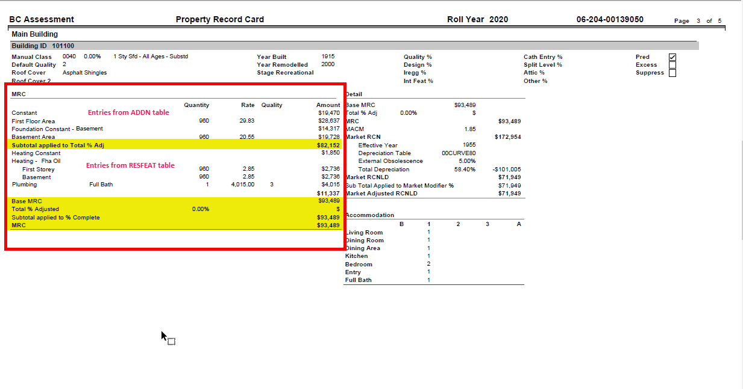

# Appendix B:

